**AI ASSISTED CODING**

**ASSIGNMENT 7.4**

LAB NAME: AI ASSISTED CODING

Enroll no :2503A51L33

Batch :20

NAME : Thirumalakonda Shiva

**TASK 1:** Introduce a buggy Python function that calculates the factorial of a number using recursion. Use Copilot or Cursor AI to detect and fix the logical or syntax errors.

**PROMPT: Buggy version**

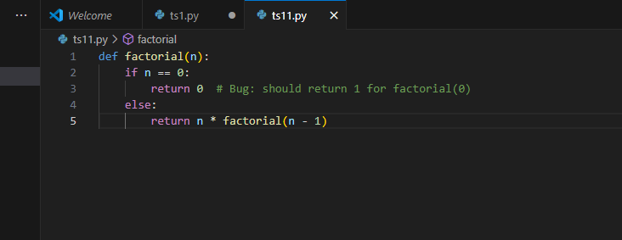

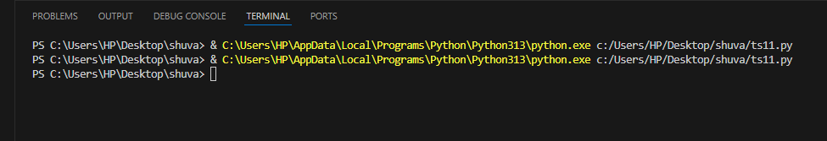

**FIXED VERSION:**

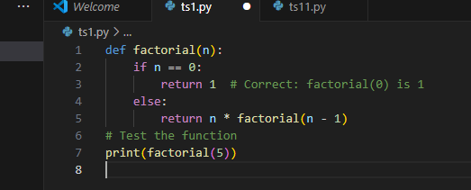

OUTPUT:

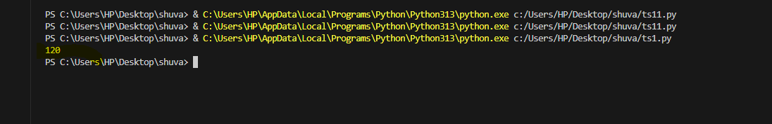

**TASK 2:** Provide a list sorting function that fails due to a type error (e.g., sorting list with mixed integers and strings). Prompt AI to detect the issue and fix the code for consistent sorting**.**

**PROMPT: Buggy version**

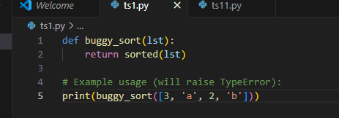

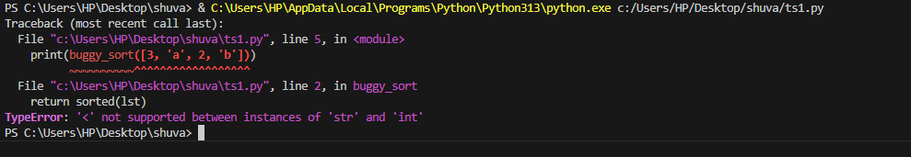

**FIXED VERSION:**

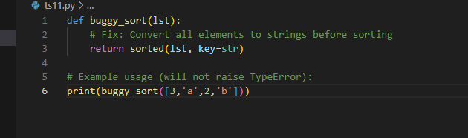

**Output:**

**8.PNG**

**TASK 3:**  Write a Python snippet for file handling that opens a file but forgets to close it. Ask Copilot or Cursor AI to improve it using the best practice (e.g., with open() block).

**PROMPT: Buggy version**

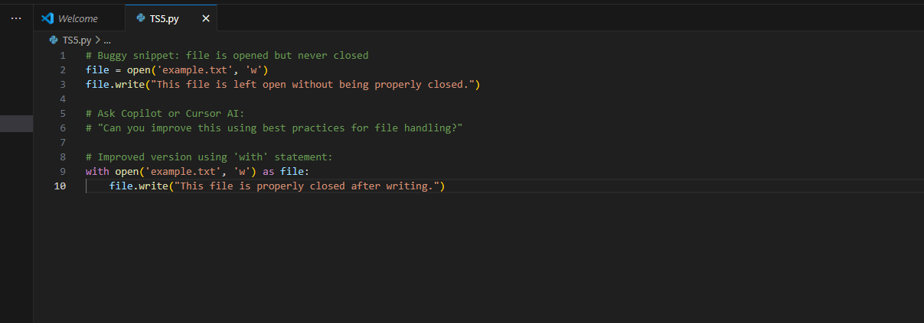

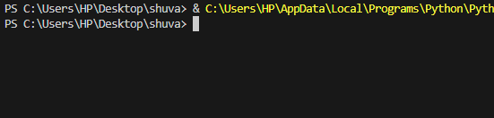

**FIXED VERSION:**

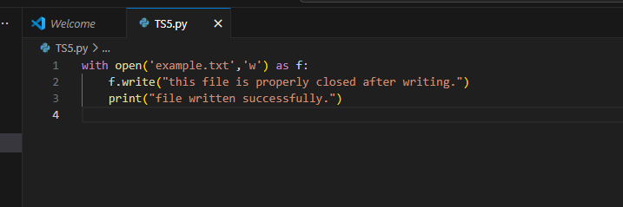

**Output:**

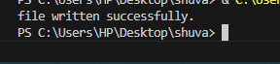

**TASK 4:** Provide a piece of code with a ZeroDivisionError inside a loop. . Ask AI to add error handling using try-except and continue execution safely.

**PROMPT: Buggy version**

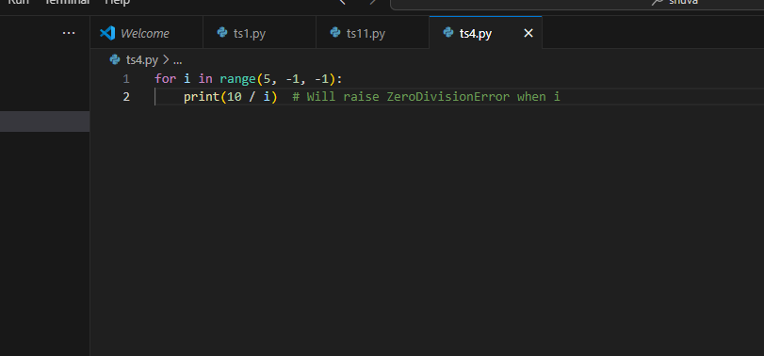

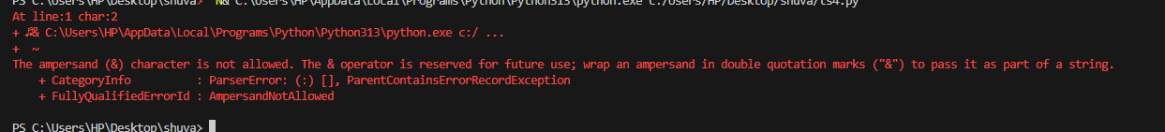

**FIXED VERSION:**

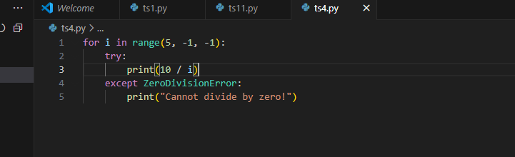

**Output:**

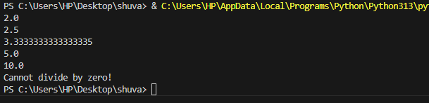

**TASK 5:** Include a buggy class definition with incorrect __init__ parameters or attribute references. Ask AI to analyze and correct the constructor and attribute usage.

**PROMPT: Buggy version**

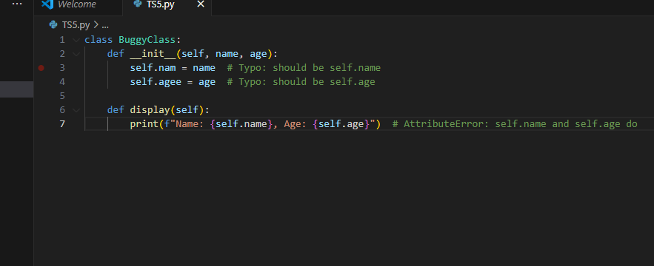

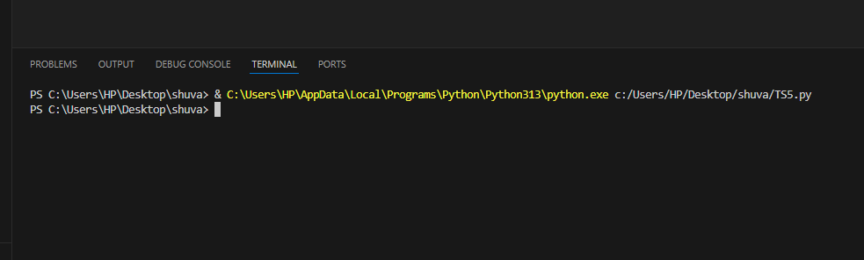

**FIXED VERSION:**

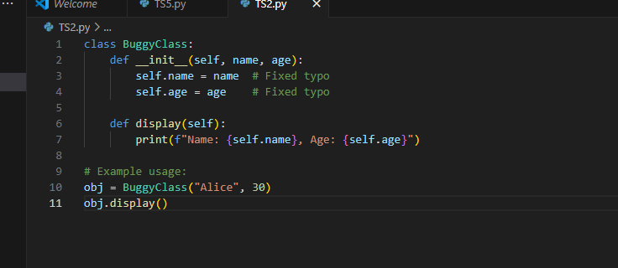

**OUTPUT:**

